RMIS QA Review and Findings
HOME LANDING PAGE:
- The Home Landing Page should have the header of “Job Opportunities” instead of “Open positions” to also match the “Positions” page/tab for cohesiveness. To remove the “4 open” box; it looks like an unclickable button. (website slug: /#/home)
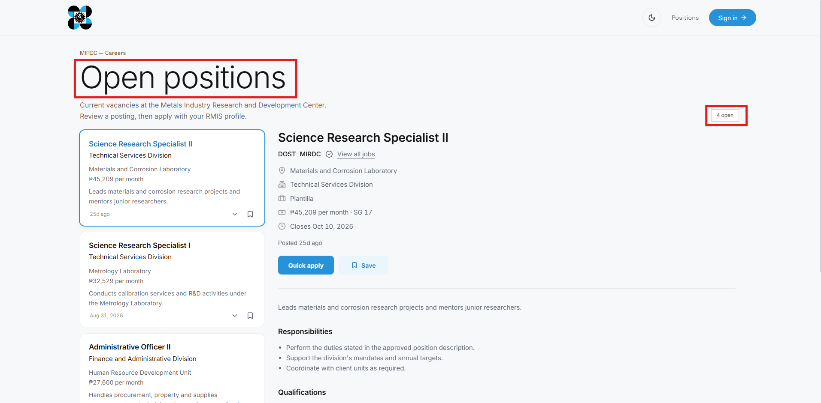

- The Positions Page header should also be named “Job Opportunities” or, if you really want to establish page distinction, it can be named “Vacant Positions”. The subheader is unnecessary. Add a checkbox for Position Category: Plantilla and COS. Change the following to:
- Open Positions to Job Openings
- Job Opportunities to Vacant Positions (or retain Job Opportunities)
- And remove “4 open positions at DOST-MIRDC.”
One observation I noticed is that the Website Page Name should match the website slug for better web routing and a less confusing system structure for all end-users. (website slug: /#/job-opportunities or /#/vacant-positions)
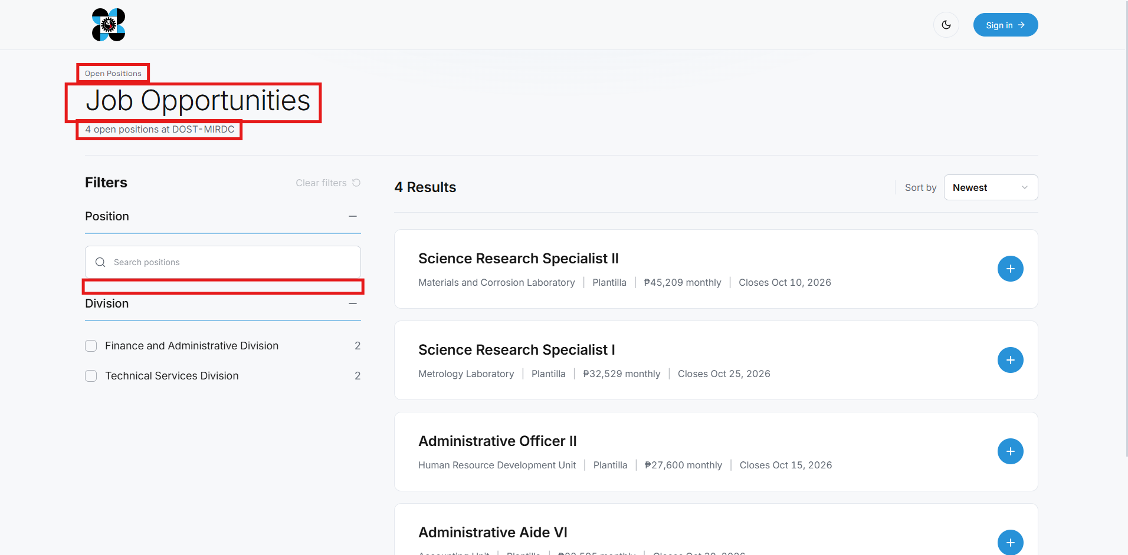

- The Sign-In Page should have a forgot password option for applicants, evaluators, and administrators near the password text box or beside “Create an account”. “RMIS – Recruitment portal” should be completed as “Recruitment Management Information System”, not Recruitment portal. (website slug: /#/sign-in)
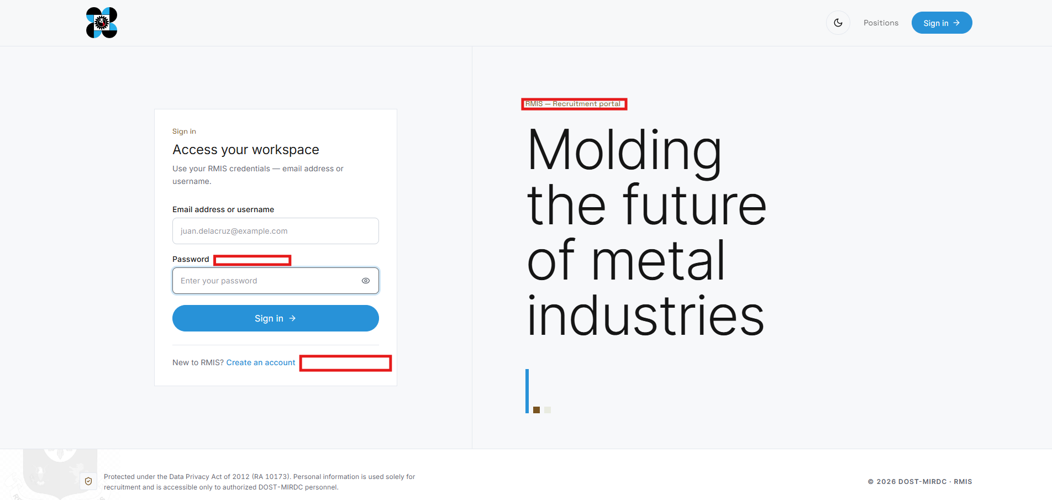

APPLICANT MODULE:
- Guided Tooltips for New Users
Consider adding guided tooltips or an onboarding tutorial for first-time users to help them understand the system and complete the initial sign-on/application process. Similar to the approach used in the IT Helpdesk system, users may be given the option to proceed with the guided tutorial or dismiss/skip it.
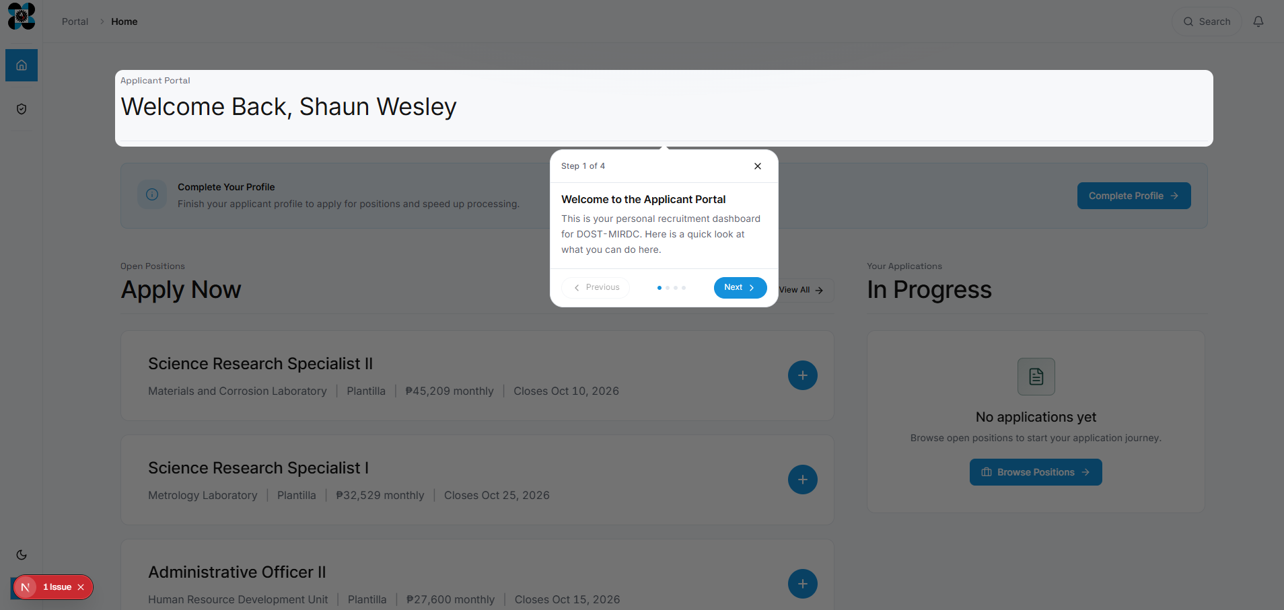

- PDS Upload – Processing Failed Error
The “Uploading of PDS” function currently returns a “Processing failed” error indicating that an unexpected error occurred. It is unclear whether this is due to a system permission/configuration issue, file type formatting and version, or another validation requirement.
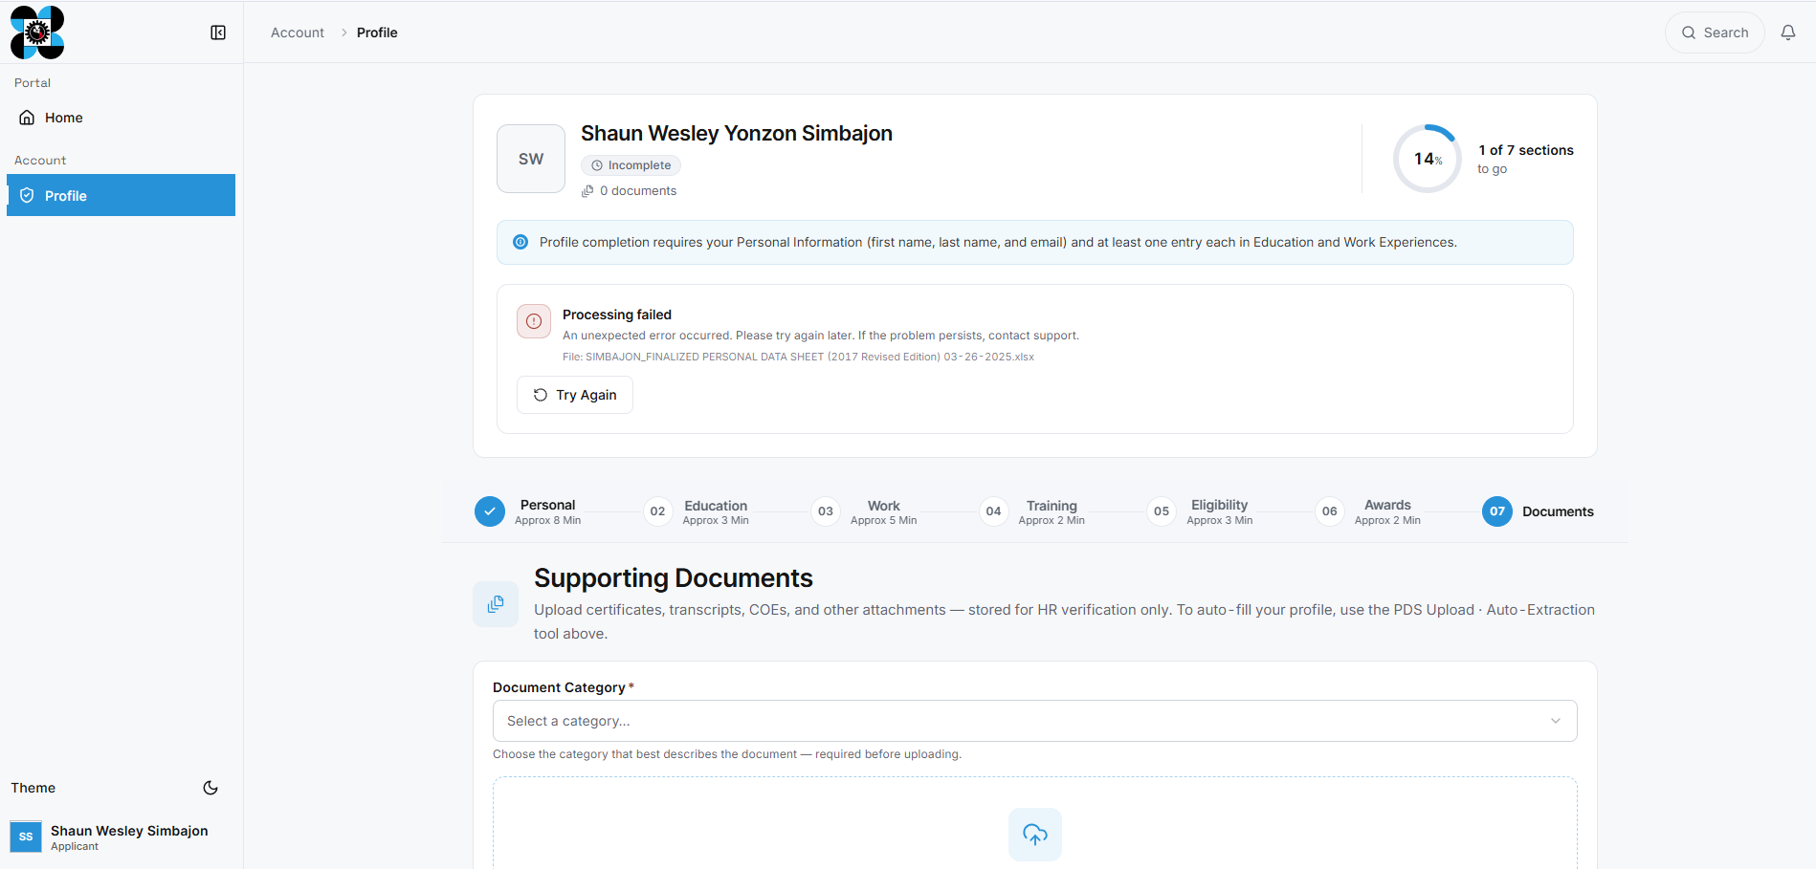

The system acknowledges that a document has been uploaded, yet it does not auto-populate the fields with data from the PDS document; it may support only a limited list of file types, formats, and versions. (The system should also support previous Excel versions, including 2019 and older.)

Recommendation: Verify the user permissions and upload functionality. Applicants should be able to upload their completed Personal Data Sheet (PDS) seamlessly as part of the application process.

- Personal Data Sheet Form – Navigation to the Next Section
While completing the PDS form, it was not immediately clear how to proceed to the next section or submit the information. I spent some time looking for a button or indicator that would allow me to continue completing my profile.
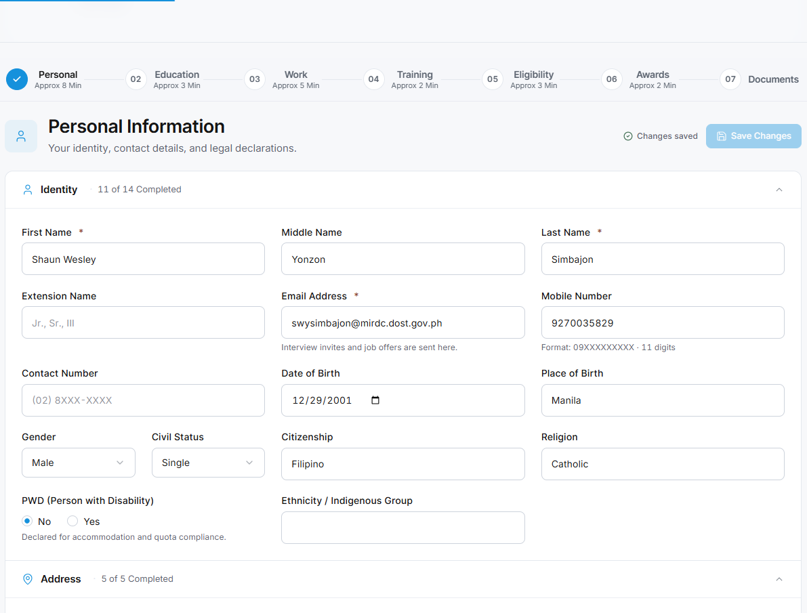
Recommendation: Add a clear “Next,” “Continue,” or equivalent navigation button/indicator to make the progression between sections more intuitive.

- Vacancy Field in Job Opportunities
The purpose and appropriate use of the “Vacancy” field in the Job Opportunities listing may need to be clarified.
For Plantilla positions, each position generally has a specific and unique Plantilla Item Number, resulting in a 1:1 relationship between the position and the item number. Because of this, the number of vacancies may not necessarily need to be specified separately for each Plantilla listing.
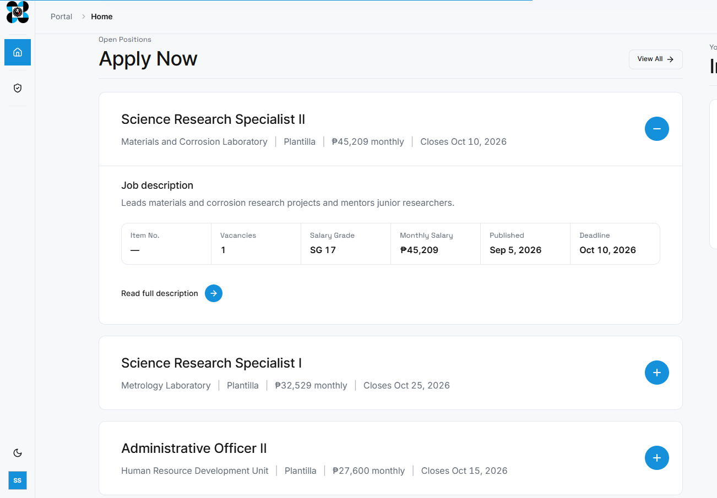
However, for Contractual/Contract-of-Service (COS) positions, there may be no corresponding Plantilla Item Number, or multiple numbers of vacancies can be associated with a single job listing.

Recommendation: Review the intended use of the Vacancy field and consider whether it should:
- apply only to Contractual/COS positions;
- be optional for Plantilla positions; or
- support multiple vacancy counts for a single job listing where applicable.
The field should clearly distinguish how vacancies are represented for Plantilla versus Contractual/COS positions.

ADMIN MODULE:
- The ADMIN MODULE contains features such as:
- Dashboard – Provides a live overview of recruitment operations.
- Jobs – Provides functionality for administrators to create, view, modify, publish, and manage job recruitment listings.
- Candidates – Rename “Candidates” to “Users” if the intended function is to provide administrators with a list of all registered system users.
- Review – The Review function may be retained as an existing feature, particularly if administrators may need to access or assist with recruitment review activities. However, the system should clearly define the scope of administrator access to this module to avoid unnecessary overlap with the responsibilities of evaluators.
- Analytics – The Analytics module may include recruitment-related analytics. For the Admin Module, it may also be useful to include system/web usage analytics, particularly information relevant to monitoring the performance and usage of the RMIS. Recent system activity and security/audit logs may also be included or linked from this section, depending on the intended system architecture.
- Settings – The Settings section may contain administrative configuration and management functions, including:
  - Users & Security – account and access management;
  - Audit Log – records of significant system activities and administrative actions;
  - Email Notices – configuration and management of system-generated email notifications; and
  - Contact Requests – management of inquiries or requests submitted through the system.
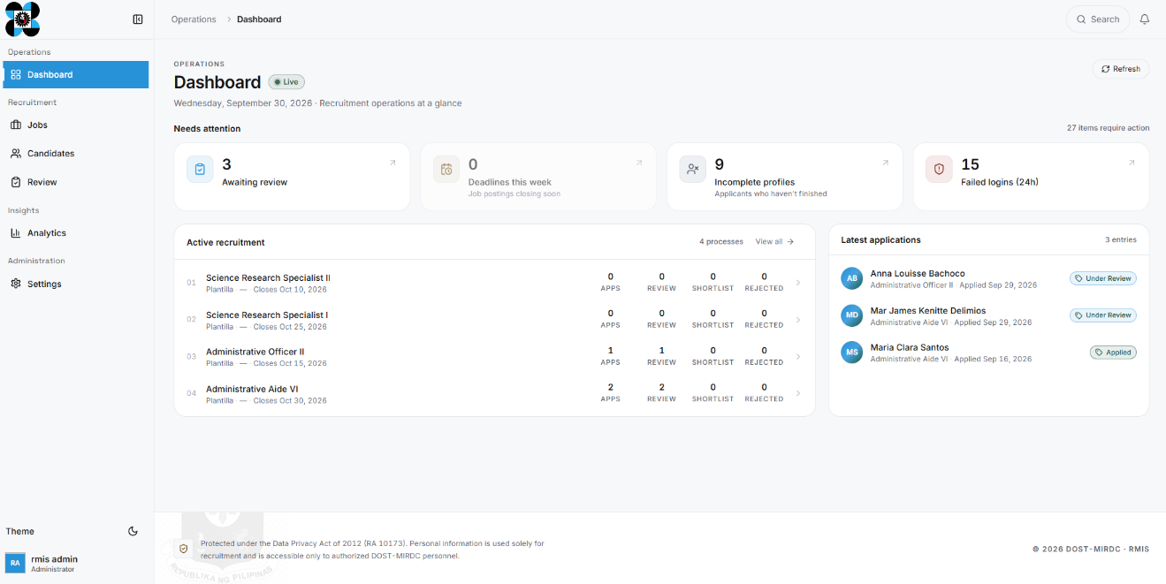
EVALUATOR/HR MODULE:
- The EVALUATOR MODULE contains features such as:
- Dashboard – Provides a live overview of recruitment operations.
- Jobs – Create, view, modify, publish, and manage job recruitment listings.
- Candidates – A list of all candidates who have already applied to a job listing.
- Review – For reviewing applicants' or candidates’ qualifications.
- Analytics – Analytics here should only display recruitment-related analytics.
- Settings - The Settings section may contain administrative configuration and management functions, including:
  - Email Notices – management of system-generated email notifications; Contact Requests – management of inquiries or requests submitted through the system.

